1) Project Information
NWT CIMP # | 186
Project Title | Building a NWT Permafrost Database: Standardizing the reporting, archiving and dissemination of permafrost ground temperature and geohazard information.
Project length (years of CIMP funding) | April 2016 - 2019
Date Submitted
Author(s) & their Organizations:  (add rows as appropriate) | Steve Kokelj – NTGS  Kumari Karunaratne – NTGS  Ashley Rudy – NTGS  Sarah Gervais - NTGS  Peter Morse – Geological Survey of Canada  Sharon Smith – Geological Survey of Canada  Trevor Lantz – University of Victoria  Ed Hoeve – TetraTech  Robert Fraser – Canadian Centre for Remote Sensing
Contact Information  Include mailing address, email, telephone and website | Steve_Kokelj@gov.nt.ca  (867) 767-9211 x63214  www.nwtgeoscience.ca
Type of Research | ☒ Science ☐ TK
Valued Component  Check all that apply. If ‘other’ please specify. | ☐ Caribou ☐ Fish ☐ Water ☒ Other  Permafrost
Geographic Area/Region | ☒ North/South Slave ☒ Dehcho ☒ Sahtu  ☒ Gwich’in ☒ ISR ☒ Wek’èezhii
Project Keywords (at least 4) | Permafrost, ground temperature, ground ice, disturbance, data management, protocols
Location In decimal degrees (dd.mmm) provide coordinates for the general study location; or if regional, provide 4 coordinates for the bounding box. | All of Northwest Territories
Consent  I acknowledge that the completed report will be posted for public access on the NWT Discovery Portal. |  | ☒ I agree
2) Abstract
Clearly and concisely identify in 300 words or less, the purpose, methodology, results and conclusions of the project.
Permafrost data collected for research, resource development projects, and infrastructure design are of increasing societal value as climate change impacts intensify. Although this information is necessary for terrain assessment, infrastructure planning and management, and climate change adaptation, data usually reside with the organisations that collected them rather than those best suited for their management, archiving and dissemination. There is a strong need for integrated collection, management, and dissemination of permafrost data among producers, users, and other stakeholders.

The Government of Northwest Territories (GNWT) and project partners recognize that permafrost data compilation, management, and public accessibility through the development of an NWT Permafrost Database provides a foundational tool for infrastructure management and climate change adaptation in the Northwest Territories. To develop a collaborative framework that links permafrost data to researchers, planners and managers, a committee including government, industry, and academic data producers and users prepared and tested a workflow, metadata templates, and reporting protocols to capture permafrost data from historical, ongoing and future initiatives.

An initial effort to compile historical data resulted in a total of 537 ground temperature datasets and 194 geotechnical projects from government, academic and industry partners, which included ~22,183,500 ground temperature data points and 4786 geotechnical boreholes. These datasets have been formatted according to the developed metadata templates and reporting protocols, and will be published beginning August 2019. Using these datasets, initial results include compilations and syntheses of available data for the Dempster and Inuvik to Tuktoyaktuk Highway (ITH) climate change-infrastructure research corridor. Significant investment in research and infrastructure development have produced high-quality climate, permafrost temperature, geotechnical and spatial datasets. Initial data interpretation is quantifying ground temperature variability along latitudinal and ecological gradients in natural and built environments, and advancing ground ice and terrain sensitivity mapping.

3) Introduction
This section should include the background, purpose, rationale and objectives of the project.
The purpose of this project is to develop a permafrost data management system that will improve the organization and accessibility of the data and contribute positively to environmental and regulatory monitoring in the NWT. The specific objectives of this project are as follows:
- Develop standard reporting protocols for ground temperature data, and geotechnical and permafrost terrain disturbance data.
- Work towards developing and implementing a data management strategic plan to guide the collection, management and dissemination of permafrost ground temperature and geohazard mapping data.
- Work towards developing, populating and sustaining an NWT user-friendly publically-accessible permafrost database
- Perform research with permafrost data concurrently with the development of the database in order to ensure its relevance and usability.
- Report on the state of permafrost in the NWT.

4) Methods
This section should clearly identify the study area, and methods used to collect and analyze the data.
A Stakeholder Advisory Committee was developed to outline the strategic plan for the project, and a Technical Working Group developed and finalized the reporting templates.

Historical geotechnical and ground temperature reports representing hundreds of locations across the NWT were acquired from Tetra Tech and Stantec. The data was extracted from these reports and compiled using the developed ground temperature and geotechnical templates. Ground temperature and ground ice data from GNWT-CIMP supported permafrost projects was also compiled and is being published in NTGS Open reports (seven reports by August 2019). More recently collected data from the Dempster and Inuvik-Tuktoyaktuk Highway (ITH) corridors have also been transferred to this format to ensure consistency between datasets moving forwards.

5) Results
In this section, the results of the project must be provided. Appropriate values for all statistical tests, if applicable, must be reported. Figures and tables should be included where appropriate.
A total of 537 ground temperature datasets and 194 geotechnical projects were acquired from Tetra Tech, Stantec, and academic partnerships which includes ~22,183,500 ground temperature data points and 4786 geotechnical boreholes (Figure 1). These datasets represent a wealth of knowledge on permafrost conditions that will be made available to the public initially though NTGS Open Reports and ultimately discoverable through an NWT Permafrost Database.

The raw datasets will be published as data reports accompanied by a short description providing project details and supplementary information. These datasets include multi-year ground temperature records from a number of research stations and infrastructure corridors as well as geotechnical records from communities and infrastructure-related projects across the NWT. Ground temperature and Geotechnical Syntheses of the ITH Corridor were also produced summarizing datasets collected in this project
with value-added analyses for the ITH region. The organizational foundation of these datasets is the geotechnical and ground temperature templates upon which they were formatted.

A Permafrost Data Workshop, held in March 2019 in Yellowknife, brought together academics and Territorial and Federal government employees to discuss permafrost data. Results of this meeting will be provided with this report.

The second phase of a permafrost information management system involves developing and formalizing a data collection and reporting strategy, institutionalizing levers and a workflow to ensure these data are captured, organised and made public (procurement, grant reporting requirements, etc.), establishing a sustainable NWT Database solution, and securing continued support for the capacity to maintain a permafrost information system. These are foundational activities identified in the NWT Climate Change Strategic Framework and represent an emergent and rapidly growing pressure triggered by an increase in spending on infrastructure development and maintenance by Department of Infrastructure, and by the increasing need for permafrost information to support climate change adaptation planning.

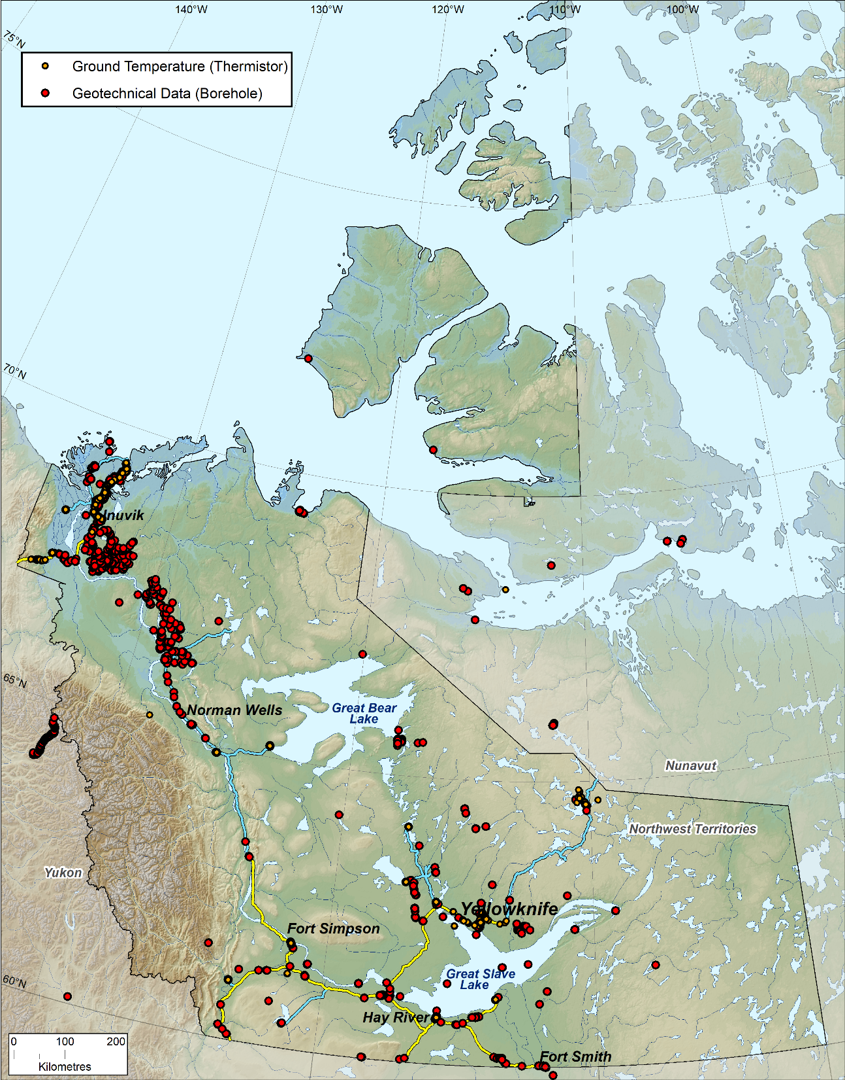
Figure 1. Distribution of compiled ground temperature and geotechnical data from across the NWT. Data is a result of academic, government and consulting projects.

6) Discussion
This section should explain the results of the project. It must also be clearly articulated how the results of this project advance the understanding of cumulative impacts in the NWT.
Our first step in this project was to establish ground temperature and geotechnical metadata, and raw data reporting templates to ensure data is described in a common format. These metadata standards were developed in consultation with technical experts and stakeholders involved with research and environmental and infrastructure performance monitoring. These templates are being published and will be available in August 2019. The goal is that CIMP adopts these protocols and provide them to permafrost-related project recipients. The Department of Infrastructure has already indicated their interest in including these templates in future contracts.

From the inception of this project, input on its design and reporting of results has occurred through a series of northern presentations including Regulatory board meetings (NWT Water Board), regional and local RRC meetings, the CIMP results workshop, NWT Geoscience forum and National and International conferences. The team has hosted workshops to obtain feedback on the proposed reporting protocols and their implementation that involve the Technical Working Group and the Stakeholder Advisory Committee. Reporting protocols were developed, and a significant amount of permafrost data was retrieved, cleaned, archived, and will be published this summer. Initial outputs using this data include Ground Temperature and Geotechnical Syntheses for the ITH (in the final stage of peer review, publication August 2019). New collaborations between the GNWT and various academic institutions are continuing research on ground ice conditions along the ITH and infrastructure stability using the data compiled in the project. We expect ongoing use of this permafrost data and outputs will take the form of scientific papers and plain language products accessible to communities and schools.
The major challenges encountered in this project can be summarized as follows: A) GNWT has had no system for managing permafrost data collected through past projects. Data recovered from one consultant alone constitutes upwards of $20,000,000.00 of permafrost-related data, which the NWT did not have in digital format. The legacy permafrost data management issue was larger than expected; B) Several groups are initiating projects that require permafrost data, neglecting the foundational need for a permafrost information management system, while also reducing resources available to complete this project (new road construction; modeling permafrost conditions in NWT); C) Lack of institutional support from GNWT to secure sustained capacity to implement and maintain the project.
The consequences are that GNWT, and other groups interested in NWT Communities and the environment will not have the information required to plan and maintain infrastructure in a cost-effective manner, nor will they have access to information necessary for climate change adaptation and decision making, despite major spending on collecting new information on permafrost conditions.

7) Resource Management Implications
In this section, describe how the results will apply to northerners, particularly environmental regulators, Aboriginal organizations, and community members. (3-5 bullets)
- This project has compiled permafrost ground temperature collected in the NWT in a standardized format. This data can be used in future projects, research, and land use decisions. Data synthesis products and publication provide new information on the NWT environment.
- Knowledge of permafrost conditions is an essential component of northern research, environmental monitoring, resource development projects, as well as infrastructure design and performance monitoring
- Permafrost information is expensive to collect, so it is fiscally responsible to organize and host these data for use in the state of environment reporting, future monitoring and development projects.
- Establishing and sustaining capacity for management of permafrost data is a critical and foundational element of preparing GNWT for climate change.

8) Project Linkages
Please state how NWT decision-makers and communities engaged in the project. Identify any new linkages that have emerged during the project and the value of those new linkages. E.g. A new decision-maker has been identified that can use the data or results. Include a list of dates and times of meetings and presentations with communities and/or decision-makers. Include a description of who attended the meetings. (Suggest 2 paragraphs)
- A permafrost data workshop was held March 5-6 in Yellowknife with attendance from several academic and Territorial and Federal government institutions. A list of participants can be found in the attached report titled, “NWT Permafrost Data Stakeholder Meeting March 6, 2019”.
- A follow-up workshop will be held at the Geoscience Forum in November 2019.
Key decision makers engaged in this project include Department of Infrastructure, Department of Lands, several consulting groups who collect permafrost information and make project planning and design related decisions for the GNWT, industry and NWT communities as clients.

9) Contribution to understanding
This section demonstrates the progress that has been made over the life of the project.
Part 1: Check all boxes that apply for the entire project life, and provide a brief explanation in Part 2.
Part 2: Provide a brief description and explanation of each of the areas checked in Part 1. Use clear language that will be understandable by those who are not experts in the project area. Provide enough detail to give an understanding of the progress that was made and its significance. It should be clearly articulated how the project advances the understanding of cumulative impact monitoring in the NWT.
Part 1
Monitoring and research conducted during the project life led to:
New or enhanced knowledge in the field of study | ☒
New or enhanced knowledge of cumulative effects | ☐
Directly impacted a current decision-making process | ☒ | 1,3
Could contribute to a future decision-making process | ☒ | 5
Development of a standardized monitoring protocol(s) | ☒ | 2
Adoption of standardized monitoring protocol(s) by decision-maker | ☒ | 1,2,4
Responded to a community concern | ☒ | 5
New or enhanced community capacity | ☒ | 2
New or enhanced analytical tool | ☐
New or enhanced modeling capacity | ☐
Other (please specify, insert rows as required) | ☐
Part 2 - Must provide evidence that the project results have been directly used in a NWT environmental decision-making process between April 1, 2017 and March 31, 2018.

- This project has compiled permafrost ground temperature collected in the NWT in a standardized format. This data can be used to in future projects, research, and land use decisions. Data synthesis products and publication provide new information on the NWT environment.
- This project developed standardized protocols for reporting ground temperature data and geotechnical data. The protocols have gone through peer review and will be published by August 2019.
- The project is a pilot study illustrating the challenges associated with developing permafrost information management systems foundational to GNWT in a scenario where government has a strong goal of major road development, fiscal restraint and developing informed climate change adaptation strategies and plans
- Developing a permafrost data management strategy. Data reporting methods have been implemented for new data along northern infrastructure corridors and will be included in contracts where appropriate. For example, the Geotechnical Data Template will be included in contracts let by the Department of Infrastructure as a deliverable to ensure that permafrost data is returned to the GNWT and made publically available. Government wide buy-in is critical to ensure implementation.
- The compiled data is being made publically available and will be used by multiple stakeholders. to ensure development of sustainable and sound infrastructure. The data is also being used by collaborators to strategically develop technical and research programs.
- This project contributes to the understanding that effective permafrost data management is not possible without dedicated technical capacity.

10) Recommendations
In this section, provide recommendations regarding how the results of the project can be applied to advance the understanding of cumulative impacts in the NWT or how NWT CIMP can help to continue the transfer of this knowledge to NWT decision-makers and communities. Projects should clearly describe how the results and knowledge generated from the project could be used to make effective resource management decisions. Please explain the next steps to this project, if applicable.
- Sustained capacity required for permafrost data management given the growing climate change relevance of this information, the magnitude of data being collected by GNWT and other parties, and the large cost of the data.
- Technical capacity for permafrost data management should reside with NTGS, but lead department with overarching climate change mandate could support with assisting in database development and instituting data management strategies across departments.
- Database to host permafrost and climate change relevant environmental data is required.
- Item 3 requires financial and capacity commitment from GNWT, otherwise, data collection will proceed on a project by project basis, increasing inefficiencies, compromising informed decision making and limiting the potential for effective implementation of climate change actions, including infrastructure and adaptation planning, and community hazard assessment.

11) Key Messages
Provide (in bullet form) the key messages and/or results of this project. Maximum of 5 bullets. These are high level summary points.
    - Knowledge of permafrost conditions is an essential component of northern research, environmental monitoring, resource development projects, as well as infrastructure design and performance monitoring
    - Permafrost information is expensive to collect, so it is beneficial to organize and host these data for use in the state of environment reporting, future monitoring and development projects.
    - The project identified historical and ongoing ground temperature and geotechnical data collections so that the metadata and raw data can be archived.
    - The project is working to develop similar reporting protocols and data recovery activities for ground ice information and permafrost disturbances.
    - The project is also working with other departments in the Government of the Northwest Territories and northern agencies to develop strategies that leverage ground temperature data and geotechnical data to make it accessible through a data management system.

12) Anticipated Publications
Please provide a list of anticipated publications related to the project. Include the title, the type of publication and the expected date of completion.
These will be provided to CIMP as they become available.
    - Guide to producing a geotechnical data report, NTGS Open Report, August 2019
    - Guide to producing a ground temperature data report, NTGS Open Report, August 2019
    - 2013-2019 Inuvik-Tuktoyaktuk Highway Region Ground Temperature Data Synthesis, NTGS Open Report, September 2019
    - 2013-2017 Inuvik-Tuktoyaktuk Region Geotechnical Borehole Data Synthesis, NTGS Open Report, September 2019
    - Scotty Creek Ground Temperature NTGS Open Report, August 2019
    - Peel Plateau Region Ground Temperature NTGS Open Report, August 2019
    - N-Slave Region Ground Temperature NTGS Open Report, August 2019
    - ITH Corridor Geotechnical Data NTGS Open Report, August 2019
    - ITH Corridor Ground Temperature Data NTGS Open Report, August 2019

List of Published Journal Articles
(These have been provided in previous reports)

Kokelj et al., 2017. Ground temperatures and permafrost warming from Forest to Tundra, Tuktoyaktuk Coastlands and Anderson Plains, NWT, Canada. Permafrost and Periglacial Processes.

Kokelj et al., 2017 Climate-driven thaw of permafrost preserved landscapes, northwestern Canada. Geology.

Rudy et al., in press. A new protocol to map permafrost geomorphic features and advance thaw-susceptibility modelling. American Society of Civil Engineers.

13) Acknowledgements
If applicable.
Polar Knowledge Canada; Department of Infrastructure, GNWT; Climate Change Group, Environmental and Natural Resources; Geological Survey of Canada; BGC Consultants; Carleton University; Wilfrid Laurier University.

14) Literature Cited
Final reports must provide appropriate citations.
15 ) Appendices
Attach Appendices as appropriate.

Email your submission to: NWTCIMP@gov.nt.ca

Final Report Submission Form Checklist
Completed annual reports must be sent to NWT CIMP electronically and must be received on or before the deadline date to be considered eligible for continued funding. All information required for the evaluation of your project must accompany the report, including all deliverables. NWT CIMP may request additional information after review of the report.

A complete annual report should include:
- A complete final report form.
- A complete final budget.
- All deliverables stated in section 6 of the annual report. If not available, provide reason.
- Other supporting information (if applicable) such as site maps, photos, plans and specifications.

Contact Us!
DonnaMarie Ouellette
NWT Cumulative Impact Monitoring Program
Department of Environment and Natural Resources

(867)767-9233 ext. 53081
nwtcimp@gov.nt.ca

