Broad whitefish community-based monitoring program: Sampling protocol

Filling the data sheet

There are two data sheets that you will use each day. One is called the “Harvest record”, which is used to record the total number of fish that you caught each day, and one is used during the fish sampling (called “Fish measurements”). The “Harvest record” sheet will give us information on how many fish were captured of different species, and you will fill out one section each day. You will use the “Fish measurements” data sheet to record individual fish information. These data sheets are placed in the binder in pairs.

Fish sampling

- Once a fish is out of the net and dead, bring it to the sampling area and wipe sides of fish briefly to remove excess water

- Flip the number card to the next number, and record fish number on data sheet.

- Place fish on the scale hook, and use the hand-held scale to weigh fish. Record weight on the data sheet. Make sure this number is recorded in kilograms.
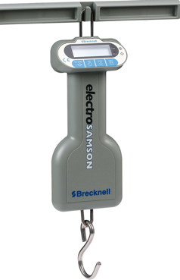
Make sure the scale screen reads “0.00” before hanging the fish to weigh

Hang fish by the gills

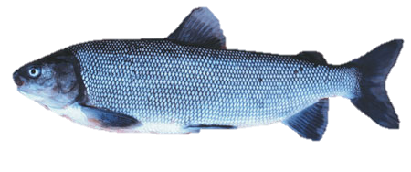

- Place fish on measuring area (a flat surface), with head facing left. Place the measuring tape on the fish and record the length from the tip of the nose to the fork of the tail (see diagram). Record this length in millimeters on the data sheet.

Place measuring tape and record
fish length along red line

- Take a photo of the fish while with the measuring tape laid on top and the number card in the top left corner. The photo should be taken by standing over the fish, using the string as a height guide. Hold the camera as level as possible. Record on the data sheet whether a photo was successfully taken.
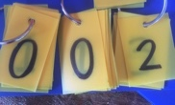
Place number card here

Measuring tape

- Write the fish number, camp name, and date on a small envelope. Using forceps or a knife, scrape about 20 scales off of the top side of the fish, about 2/3 of the way from the nose to the tail (see diagram). Place these scales on a small piece of wax paper, fold the wax paper and place in the envelope. Seal the envelope and place in a ziplock bag. Write the same number on the data sheet that is on the envelope (this should be the same as the fish number).
Collect scales from the area in the box,
three rows above the lateral line

- Rinse scissors and forceps in water, and take a small clip of the tail fin (about the size of pinkie fingernail—see diagram). The fin clip will be placed in the middle of a piece of circular filter paper. Fold the filter paper in half, then fold in the sides and the top. This will create a little packet with the fin clip in it. Write the date and fish number on an envelope and place the folded paper with the fin inside the envelope. Write on the datasheet that this has been completed.

- Write the fish number, camp name, and date on a small bag. Cut open the fish head and remove the otoliths. Clean the otoliths of any membranes, and place them in a small flip-top vial. Place that vial into the labeled bag, and place in the fish sample bag. Write the number of otoliths collected on the data sheet (ideally, you will find two, but only one might be collected).

Cut fish head here and use forceps
to remove otoliths

- As you are cutting the fish open, determine if the fish is male or female. Circle f (female) or m (male) on the data sheet.

- Record whether the fish looks ready to spawn (with large, well-developed eggs or gonads), or not. Circle “yes” or “no”.

- In the “notes” column, record whether any parasites, wounds, or a soft, white fungus is observed on the fish.

