NWT-wide surveillance of Mercury [Hg] in fish: Protocol for the opportunistic collection of fish samples to measure mercury

Purpose: To provide guidance on the collection of information, storage and shipping of samples for the purpose of determining mercury (Hg) concentrations in fish tissue.
Background: The Northwest Territories Cumulative Impact Monitoring Program (NWT CIMP) conducts, coordinates and funds the collection, analysis and reporting of information related to environmental conditions in the Northwest Territories (NWT). Its main purpose is to support resource management decision-making and the wise use of our resources by furthering our understanding of cumulative impacts and environmental trends.
Mercury (Hg) levels in fish tissue is a particular concern for communities in the NWT. Monitoring and research projects that are funded through our program are often asked by communities or governments to include investigating current levels of Hg in different fish species. NWT CIMP follows the attached protocol developed and used by subject matter experts, promoting a standardized approach to the collection, storage and analysis of Hg samples, allowing for an NWT-wide analysis of Hg in fish.
This protocol applies to NWT CIMP funded projects where:
- fish mortality will occur,
- there is an interest in determining the Hg levels in fish tissue,
- Project Leads have agreed to collect information and ship samples as described in this protocol,
- Indigenous governments and Indigenous organizations and NWT community partners are aware of the samples being collected and analyzed for Hg, and
- it can be supported within NWT CIMP’s available annual budget.
NWT CIMP is implementing an opportunistic NWT-wide surveillance of Hg in fish program to promote efficient and scientifically defensible data collection from fish that are sacrificed for other purposes. This information benefits the users of our fisheries resources as well as decision-makers.
NWT CIMP’s role in this program includes:
- providing an additional $2,000.00 for each NWT CIMP funded project that participates in this program to cover the costs of additional field work, shipping, etc.
- receiving, storing, and shipping all samples to an accredited lab,
- funding analysis and conducting reporting,
- results reporting, including regional summaries anticipated every three years, subject to data generation,
- sharing the data and analysis with those who collected the data, IGIOs, and the interested community or government partners,
- making the data publicly available in an open data file, where contributors are provided authorship, and
- sharing results with GNWT-Health and Social Services

For NWT CIMP funded projects that choose to participate in this program, the expectations are:
- Samples are to be frozen as soon as possible (-20⁰C if possible, standard freezers are acceptable),
- A standard data sheet (attached) accompanies the frozen samples sent to NWT CIMP. One form per location sampled is required, and
- IGIOs and NWT community partners are aware of the samples being collected and analyzed for Hg and
- Participating projects provide the NWT CIMP contact for any questions and follow up.

Processing Fish for Territory-Wide Surveillance of Mercury

Sample selection
- Select 5-10 individuals per species per lake that represent the full range of fish sizes that you captured.

For large-bodied species, follow all processing instructions below.

For small-bodied fishes (e.g., nine spined stickleback, sculpin spp., Young-of-Year of any spp.), assign the fish a sample number, measure and weigh them in the field, and place the whole fish in a labelled whirlpak bag.

For Great Bear Lake, Great Slave Lake, and the Mackenzie River, make sure that the sites within the waterbody are indicated on the sample bag. Stratify sample selection (5-10 individuals/species/site) if possible or applicable, but otherwise just identify the site(s) (e.g., west basin, east basin, McVicar Arm).

For lakes other than Great Bear or Great Slave, do not worry about stratifying samples by the location where they were caught in the lake.

- MINIMUM: tissue or whole-body sample in clearly labeled bag. Length, weight, site, species, and date information on data sheet.

- NICE TO HAVE: ageing structures, sex and maturity information, any other comments about fish health.

Bag Labels and Notes
- Use sterile whirlpaks for muscle (large fish) or whole body (small fish) sample collection; the ones with the frosted window are best. Use ageing envelopes for otoliths, cleithra, opercula, or scales. You may need small ziplocs for large cleithra.

- Label the bag with the fish sample number (corresponding to your data sheet), waterbody name, date, and species. Specific locations/GPS coordinates can be noted on the data sheet.

- Write down the species and anything you notice on the fish, like parasites, injuries, or anything else that is abnormal. Take a picture of the fish with the labeled sample bag or ageing envelope in the frame.

- Use the provided datasheet.

Getting Ready
- Prepare your working space by setting up a garbage area and a clean area to cut. You’ll need:

  - sample bags,
  - measuring board,
  - scale (and maybe a bucket if the fish are large),
  - aging envelopes,
  - latex/nitrile gloves,
  - water,
  - cutting board,
  - knife,
  - pair of sidecutters/wire cutters/metal snips,
  - pair of forceps.

You can rinse all your equipment – including gloves - between samples just with water.

Work from your smallest, lowest trophic-level fish, to your largest, highest-trophic level fish (e.g., large Northern Pike).

Change gloves between species, and scrub equipment (including fork length board) especially well between species.
~ Make sure to tie back long hair – human hair can contaminate samples! ~
- Label any bags you’ll be using BEFORE you get started. Mark down the date, the species, where it was caught, the fish sample number, and the tissue type on the whirlpak bag.

You may include the length and weight of the fish on the aging envelope if you have enough labeling help.

If your whirlpaks do not have a frosted window, label both sides of the bag, or include the information on a scrap of waterproof paper that you put inside the bag.

If you are going to use species abbreviations, make sure you use the AFS convention (four consonants (e.g., LKTR, NNST, SLSC, BRBT, LKWH) or first four letters if this is not possible (e.g., CISC).

Date | 25 June 2018
Species | Lake Trout
Location | Big Lake
Sample # | 001
Tissue | Muscle

- While wearing gloves, wash all the tools, cutting boards, and the table with water. If soap is necessary, rinse with plain water afterward. Lake or river water is fine.

Measuring the Fish
If you are measuring a Lake Trout, Northern Pike, Cisco, Walleye, or Whitefish or any species with a forked caudal fin:
- Measure the fork length of the fish, using a measuring tape or a fish board. Fork length is from the nose of the fish down to the middle of the tail fork. Write down the fork length in millimeters on the Data Sheet.
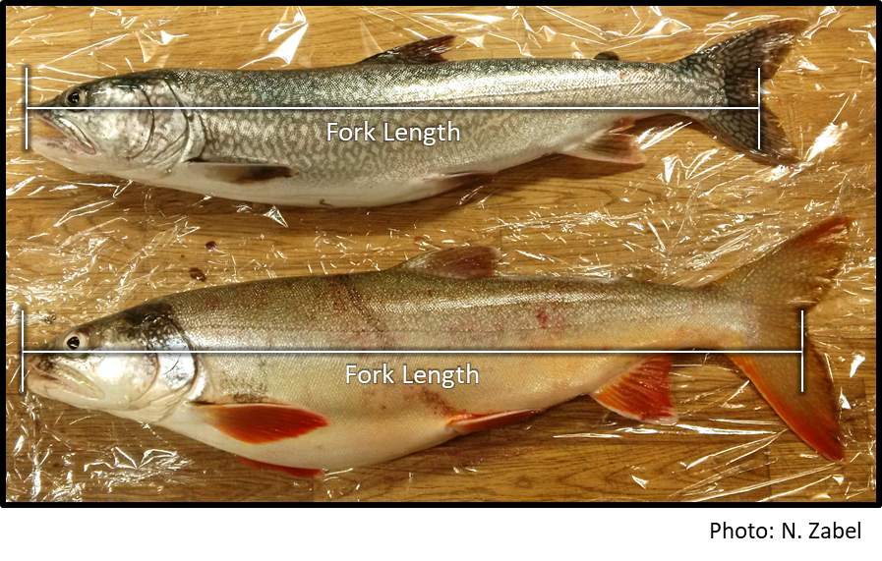
- Next, measure the total length of each fish. For some species, like Burbot (see below), you will only have a total length measurement. Total length is from the nose of the fish down to the end of the tail. Write down the total length in millimeters on the Data Sheet. See the example:
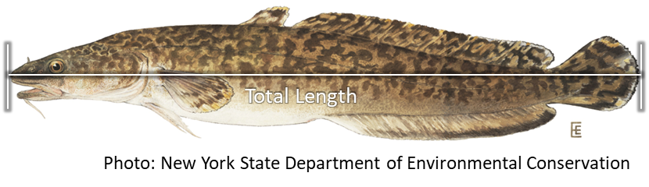
- Take a picture of the whole fish, with the labeled bag or ageing envelope in the frame.

- Weigh the fish in grams. Record this on the Data Sheet.

Collecting Tissue Samples
- Using a fillet knife or scalpel, collect a sample of dorsal muscle from the fish. The sample should be collected from the area in front of the dorsal fin and above the lateral line.

It’s easiest to start your cut if you clean scales off first, especially for whitefish. You want a piece of flesh that is approximately the size of two pink pearl erasers.

Place the tissue in a labeled whirlpak bag.

- Rinse your tools and cutting board for the next fish. Water is fine for cleaning and rinsing – you don’t need soap. If you would like to use soap when switching species or if you have had a particularly slimy pike, make sure to rinse with lots of water.

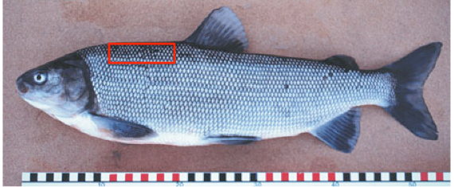
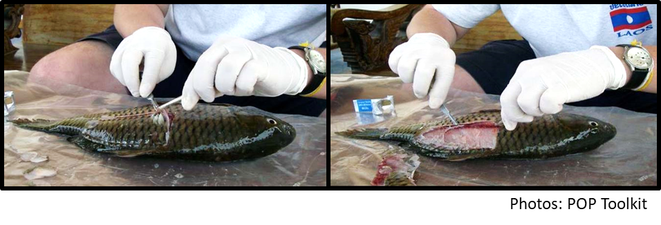
- Keep the sample as cool as possible until it can be frozen at -20 C.

- Cut open the fish along the ventral side, as if you were going to clean it. Note and record sex and maturity on the data sheet if you are able to do so. Otherwise, leave these sections blank.
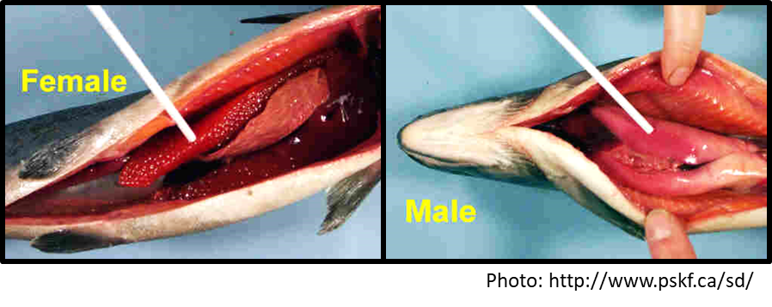
- While looking at the organs, make sure to make notes of anything unusual: tumors, odd growths, cysts, or parasites. Write these down on the data sheet.

Collecting Ageing Structures
There are recommended primary and secondary ageing structures for each fish species. To facilitate comparisons with existing data, please consult the list below for which ageing structure(s) should be collected for the species you have captured.
- Walleye, Lake Trout, any Whitefish or Cisco species, Burbot, Grayling – Otoliths.

Can collect scales as secondary for whitefish and cisco species, and opercula as secondary for Walleye.

- Northern Pike – Cleithrum (left side, if possible), can collect otoliths as secondary.

- Sucker species – First three pectoral fin rays, can collect scales as secondary.

Pre-label your ageing envelope with the species, sample number, location, and date. Other information (e.g., length, weight, sex, maturity) is great if you are able to and if you have enough help labeling. If you collect more than one structure, put both in the same envelope.
Otoliths must be cleaned and dried (membranous sac removed), and it is best if they are wrapped in a small piece of shop or paper towel, but this isn’t strictly necessary.
Cleithra and fin rays can be placed directly in the envelope or in a piece of wax paper.

Collection of pectoral fin rays (do not be confused that this picture is of a Lake Trout – illustrative purposes only).
Lift and extend the pectoral fins, near the gills: you want the longest fin rays.
Start from the longest ray and place the sidecutters/wire cutters/metal snips against the body, then cut off the 3 – 4 longest rays without drawing any blood from the fish.
Place the rays in a labeled ageing envelope.
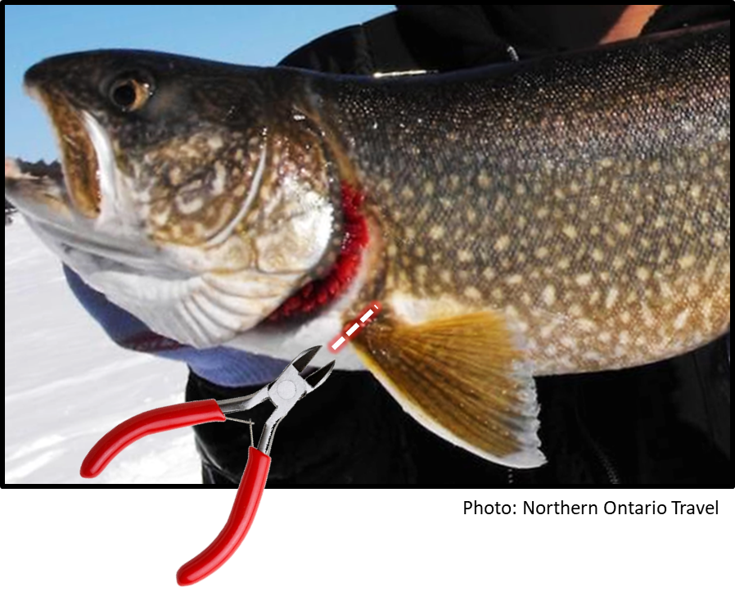

Collection of Scales
Collect ~ 6 – 10 scales from underneath the dorsal fin. Use your knife to scrape the area under the dorsal fin, to remove any dirt and mucus.
Wipe the knife clean.
Scrape the clean area to remove the scales, then carefully wipe the scales into the labeled ageing envelope.
Make sure there are no wounds in the area where the scales are being removed.

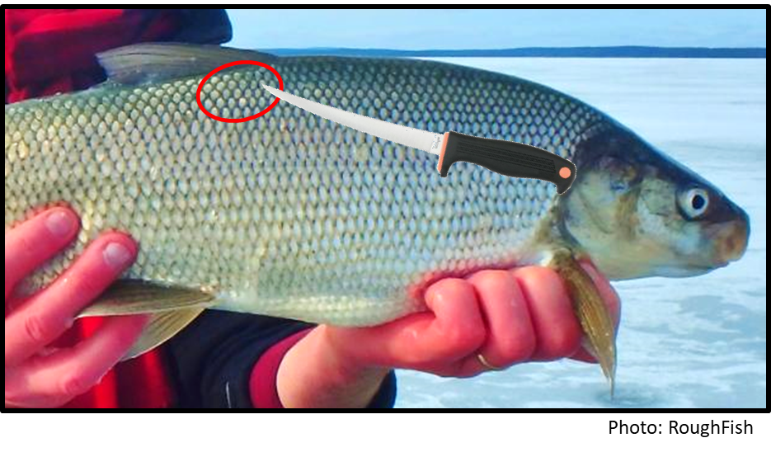

Collection of Cleithra
The cleithrum is found under the gill flap: it is a white/clear bone structure. Lift up the gill flap, and you’ll be able to see the cleithrum.
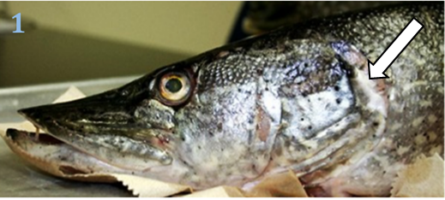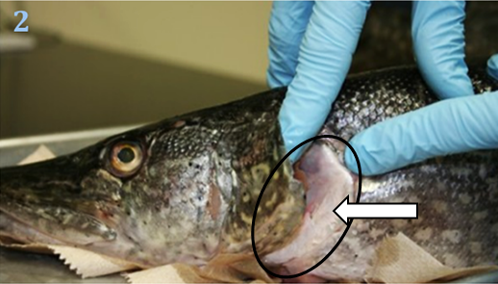
Push your thumb under the cleithrum and the other tissues, running along the cleithrum to free it slightly.
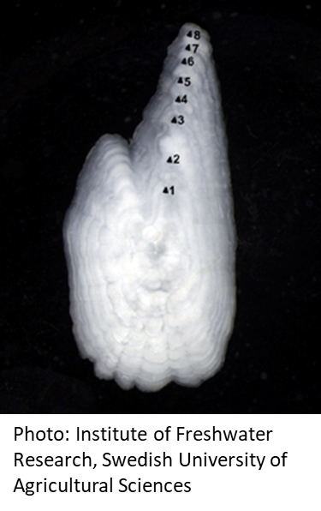
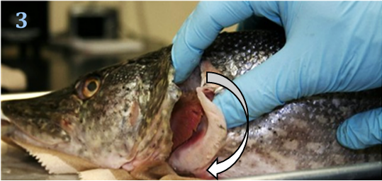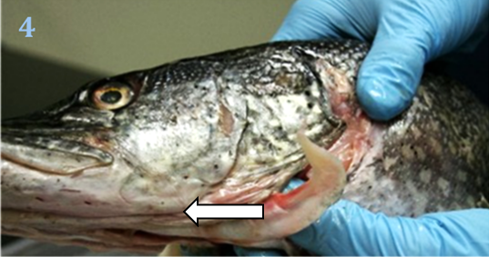
Once it is separate, pull it slowly away from the gills and towards the head of the pike. Be careful, the part under the jaw breaks easily! If you think it might break, use your knife or scissors to finish separating it.
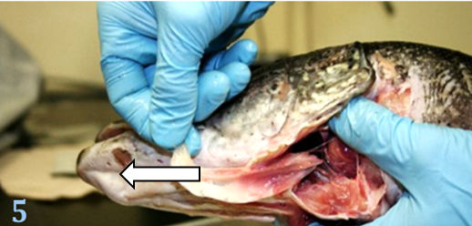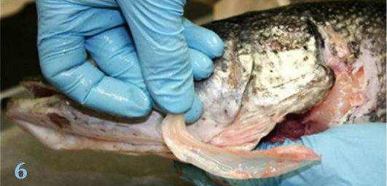
Clean off any extra flesh, then place it in the labeled ageing envelope.
Photos: Vermont Fish & Wildlife (http://www.vtfishandwildlife.com/images/pike)

Collection of Otoliths
Removing otoliths can be done in several ways. There is one way shown here (head off – works nicely for salmonids), but of course use whatever technique you are most comfortable with/efficient at (e.g., from the top, from the bottom, etc).
Remove the head of the fish, ahead of the gill cover. Make sure to remove the head in a straight cut down.
Stand the head so the mouth is facing up.
Starting at the top of the eyes, use your knife to cut straight down, in order to expose the brain. Remove any flesh that is covering the brain, if necessary.
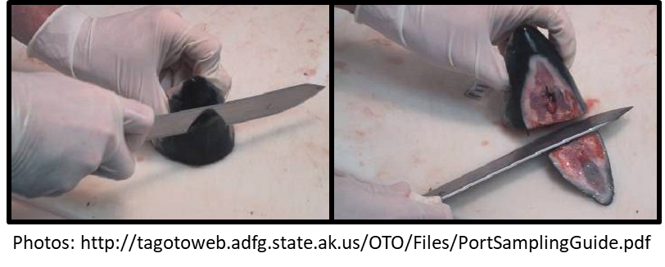
The otoliths should be visible through the top of the head, inside a small cavity. Remove both otoliths with forceps. Place them on the back of your hands on your gloves.

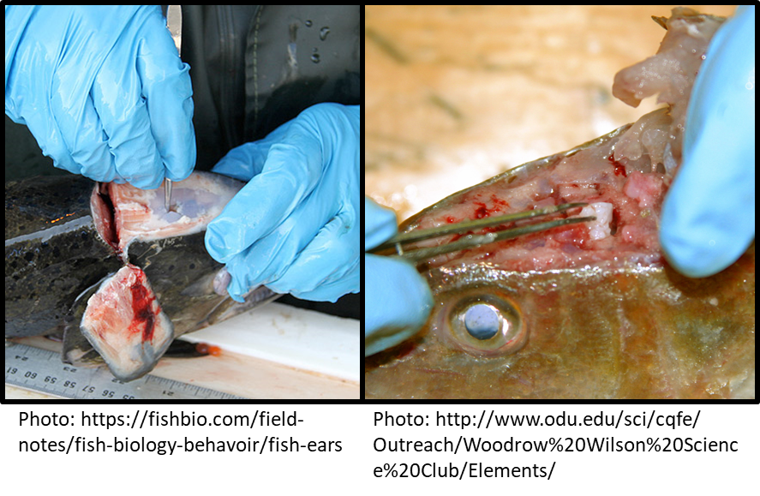

Example photo of otoliths:
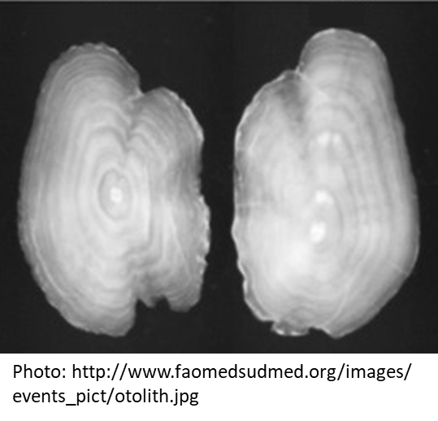
Use a finger from your other hand to gently remove the fluid and sac around the otoliths.
Dry the otoliths and place them in a labeled aging envelope (ideal if they are in a folded piece of paper, shop towel, or paper towel, especially if you have a second structure in the envelopes.

Data sheet
Once you have collected your samples, make sure the species, fish number, location, date, length, weight, etc are consistent on the data sheet, the tissue/whole-body bag, and the ageing envelope.
Fish Processing Checklist – Bolded items are mandatory
☑ | Species
☑ | Fish Number
☑ | Location
☑ | Date
☑ | Fork length and/or Total Length (mm)
☑ | Weight (g)
☑ | Sex
☑ | Maturity
☑ | Ageing Structure #1
☑ | Ageing Structure #2
☑ | Muscle/Whole-body Sample
☑ | Other observations/notes?
Once you are sure everything is written down and you’re done processing the fish, dispose of the organs and carcass according to your license/agreement with local Indigenous governments and Indigenous organizations.
Rinse all tools with water when changing fish. Wipe down your table and cutting board with water.

Sample Storage and Shipping
All samples (including otoliths) can be stored at -20C.
Samples are to be shipped frozen to:
NWT CIMP, GNWT-ECC
7th floor, Scotia Building
PO Box 1320
5102 50th Ave
Yellowknife, NT X1A 2R3
867 767-9233 ext 53088

Data Sheet: Sampling form to use

