**NWT CIMP**

**Indigenous Knowledge Data-Sharing Agreement SAMPLE Template**

**Revised August 2021**

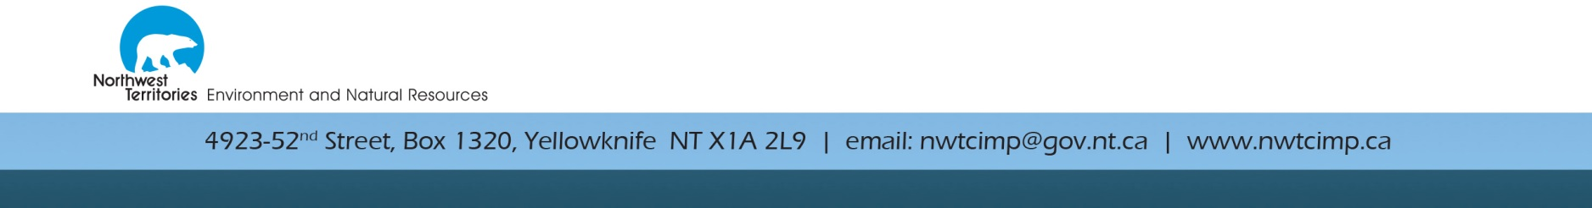

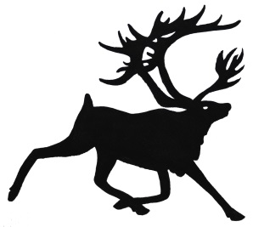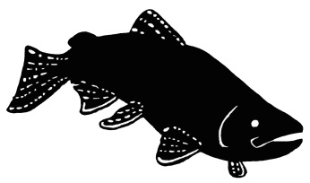

**Northwest Territories Cumulative Impact Monitoring Program**

***Definitions***

*Definitions may be included in this agreement to clarify certain terms.*

Indigenous Knowledge - The knowledge and values, which have been acquired through experience, observation, from the land or from spiritual teachings and handed down from one generation to another.

Data Sharing - The exchange, collection, use or release of data by one organization to another organization for certain purposes.

Ownership**:** Refers to the relationship of Indigenous people to their cultural knowledge/data/information. The principle states that a community or group owns information collectively in the same way that an individual owns their personal information.

Possession: While ownership identifies the relationship between Indigenous people and their information in principle, possession is more concrete. It refers to the physical control of data. Possession is a tool by which ownership can be asserted and protected.

Control:The principle of “control” asserts that Indigenous people, communities and representative bodies are within their rights to seek control in all aspects of research and information management. Indigenous control of research can include all stages of a project. The principle extends to the control of resource and review processes, creation of frameworks, data management and so on.

Access:Indigenous people must have access to information and data about themselves and their communities, regardless of where it is held. This also refers to the right of Indigenous communities and organizations to manage and make decisions regarding access.

**Indigenous Knowledge Data-Sharing Agreement Sample Template**

*This sample template assists you in drafting an agreement that meets the needs of all parties. Each project lead can modify this template as required in collaboration with communities. There is no need to complete this document if the community organization is the project lead.*

CIMP###: ____________

Project title: ______________________________________________________________

THIS DATA-SHARING AGREEMENT is made this _____ day of ________, 20__

**BETWEEN:**

**Principal Researcher(s) and Organization**

Name(s): _________________________

Organization: ________________________

Address: ________________________

________________________

Telephone: ________________________ Email: ________________________

**AND**

**_________________________________ (Indigenous government, organization or community)**

Contact person(s): ________________________

Address: ________________________

________________________

Telephone: ________________________ Email: ________________________

*Add other parties as/if required (i.e. other research partners or organization)*

This agreement will commence on and come into effect from the date of signing by the last of the parties, and will remain in effect for ___________year(s).

The Indigenous government or organization consents to enter into an agreement where the principal researcher:

1. Is authorized to use the Indigenous knowledge data for research purposes; and
2. May provide materials based on research to a third party. These may be made publically available.

***Purpose***

*Identify the purpose and reason for the agreement. The purpose must be understood and formally agreed to by those entering into it.*

The purpose of this IK data-sharing agreement is to:

1. Describe the research project purpose;
2. Describe what and how the Indigenous knowledge data is being collected;
3. Describe what Indigenous knowledge data is being shared;
4. Describe how the data will be used;
5. Describe how the data will stored;
6. Clarify issues of Indigenous knowledge data ownership, control and access; and
7. Describe the retention and disposal of data;
8. Describe amendments to the agreement *(if needed)*
9. ***Research Project Purpose (2-5 sentences from NWT CIMP Proposal)***

_______________________________________________________________________________________________________________________________________________________________________________________________________________________________________________________________________________________________________________________________________________________________________________________

**2. The following types of Indigenous knowledge data are being gathered:**

*(e.g. questionnaire, statistics, audio recording of interviews, interview transcripts, maps etc).*

________________________________________________________________________________________________________________________________________________________________________________________________________________________________________________________________________________________________________________________

**2.1 How is this Indigenous knowledge being collected?**

________________________________________________________________________________________________________________________________________________________________________________________________________________________________________________________________________________________________________________________

**3. Data Sharing**

*Identify which parties will have access to which types of Indigenous knowledge data.*

The following types of Indigenous knowledge data can only be shared confidentially with the following parties:

__________________________________________________________________________________________________________________________________________________________________________________________________________________________________________

***4. Use of Data***

Describe how the data will be used (e.g. What is the question being asked? What will the final products be? )

________________________________________________________________________________________________________________________________________________________________________________________________________________________________________________________________________________________________________________________

If the principal researcher(s) wishes to use the Indigenous knowledge data differently or for other purposes than agreed to in this agreement, they must gain prior permission of the Indigenous community, government or organization.

***5. Data Storage and Confidentiality***

*Integrity and security of the data must be maintained by instituting controls, such as ensuring that only authorized users have access to the data and that electronic systems are properly maintained and managed.*

The Indigenous knowledge data will be stored in the following ways (e.g. hardcopies, network servers protected by firewalls, etc.):

______________________________________________________________________________________________________________________________________________________________________________________________________________________________________________________________________________________________________________________________________________________________________________________________________

Confidentiality of the Indigenous knowledge data (if desired) will be ensured in the following ways:

________________________________________________________________________________________________________________________________________________________________________________________________________________________________________________________________________________________________________________________

The principal researcher(s) will store and maintain the shared data in a manner that ensures its use remains consistent with the terms and conditions of this Agreement.

***6. Data Ownership and Intellectual Property***

*The Indigenous community, government or organization retains all intellectual property rights (including copyright).*

The Indigenous community, government or organization owns the collective Indigenous knowledge data and retains all intellectual property rights (including copyright) of the data specified under this Agreement.

1. ***Retention and Disposal of Data***

*Specify how long the shared data is kept or stored. Terms should be identified regarding the disposal of the data once the agreement has expired or been revoked. The data may be returned to the source or destroyed by the recipient.*

Upon expiry of the agreement, the principal researcher(s) will immediately and permanently remove and destroy all copies, both physically and electronically, of the data provided. This does not include publically available reports or documents that discuss, summarize, or in other ways refer to the data collected under this Agreement.

1. **Amendments to the Agreement.**

This agreement may be renewed, extended or amended with the written consent of both parties at least sixty (60) days prior to the expiration of the agreement.

1. ***Signing Authorities***

*Identify signing authorities and organization of the parties involved.*

This Agreement has been executed on behalf of the parties by their authorized representatives:

_______________________ ____________________ _______________

Name Signature Date

_____________________________

Organization

________________________ ____________________ ________________

Witness Signature Date

**AND**

_________________________ ____________________ _______________

Name Signature Date

_____________________________

Organization

________________________ ____________________ ________________

Witness Signature Date